Papers written by Australian Maths Software

SEMESTER ONE

MATHEMATICS SPECIALIST
REVISION 2
UNIT 3

2016

SOLUTIONS

Section One
1. (6 marks)
(a) 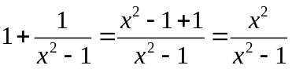 (1)
✓

(b) (5)
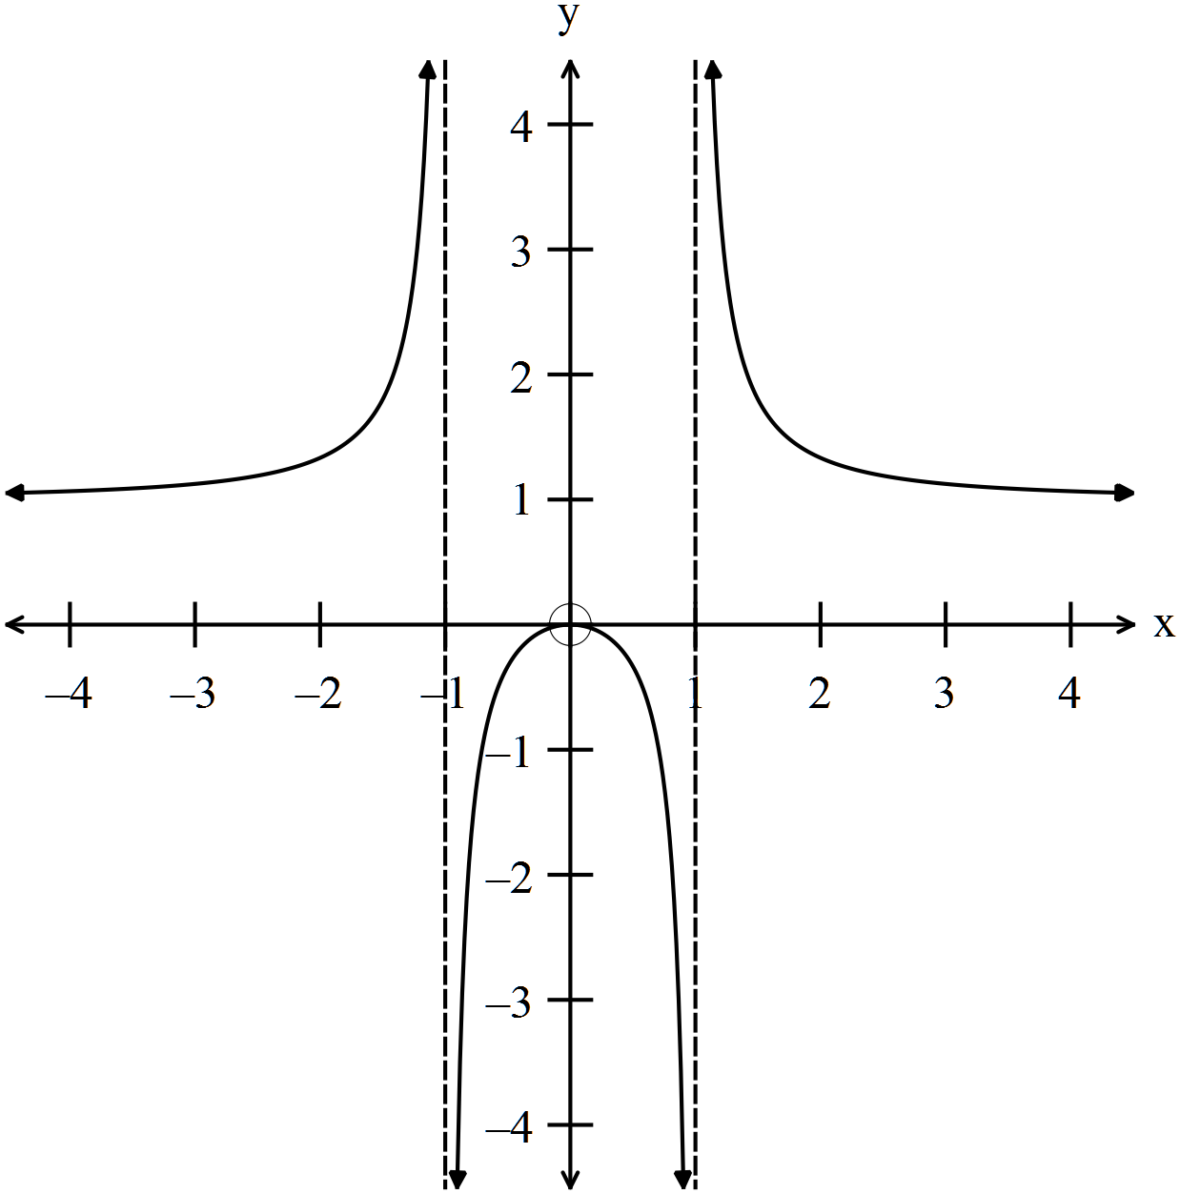
✓

✓

✓

✓

✓

2. (10 marks)
(a)
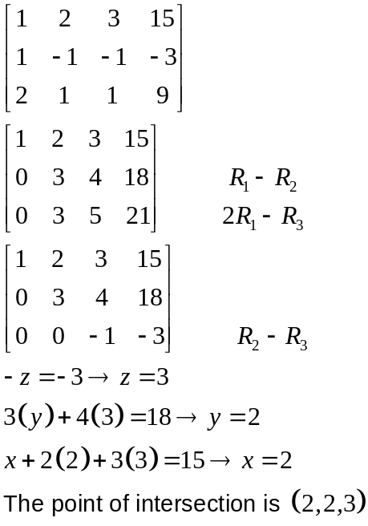
✓
✓
✓
✓
(4)
(b) 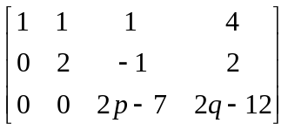
(i) Exactly one solution if 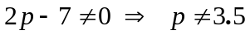 ✓✓ (2)
(ii) There is no solution if ✓✓ (2)
(iii) There are inifinitely many solutions if
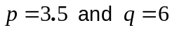 ✓✓ (2)
3. (13 marks)
✓
(a)
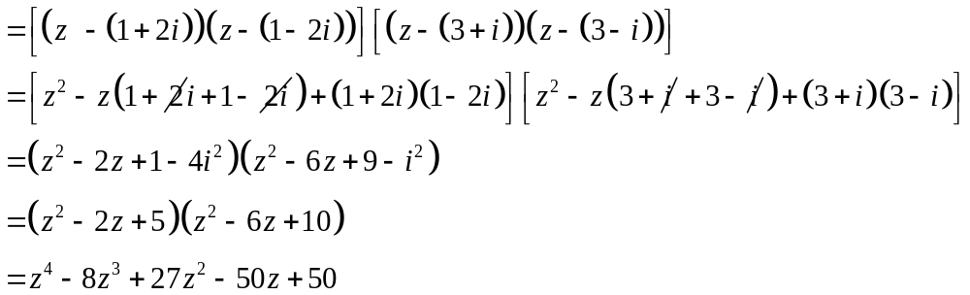
✓
✓
Therefore equation is 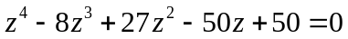
(3)
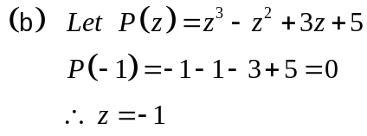
Using synthetic division with 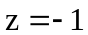 You can use long division but slower
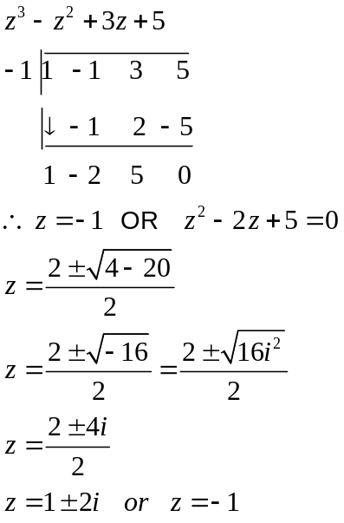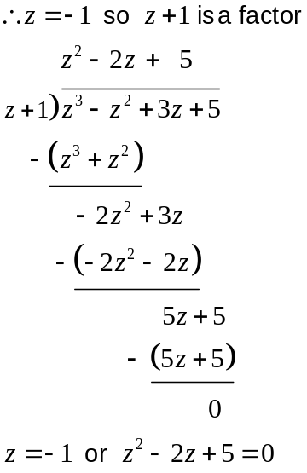
✓

✓
✓ method
✓
(c) (i) 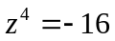

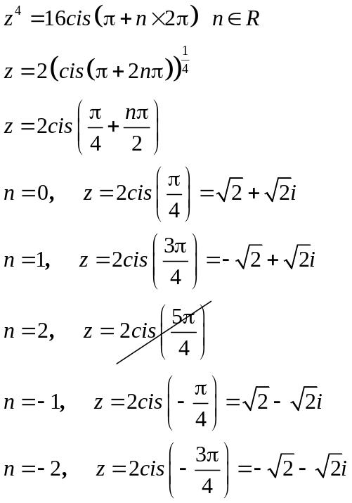 ✓✓ (3)
✓

(ii)
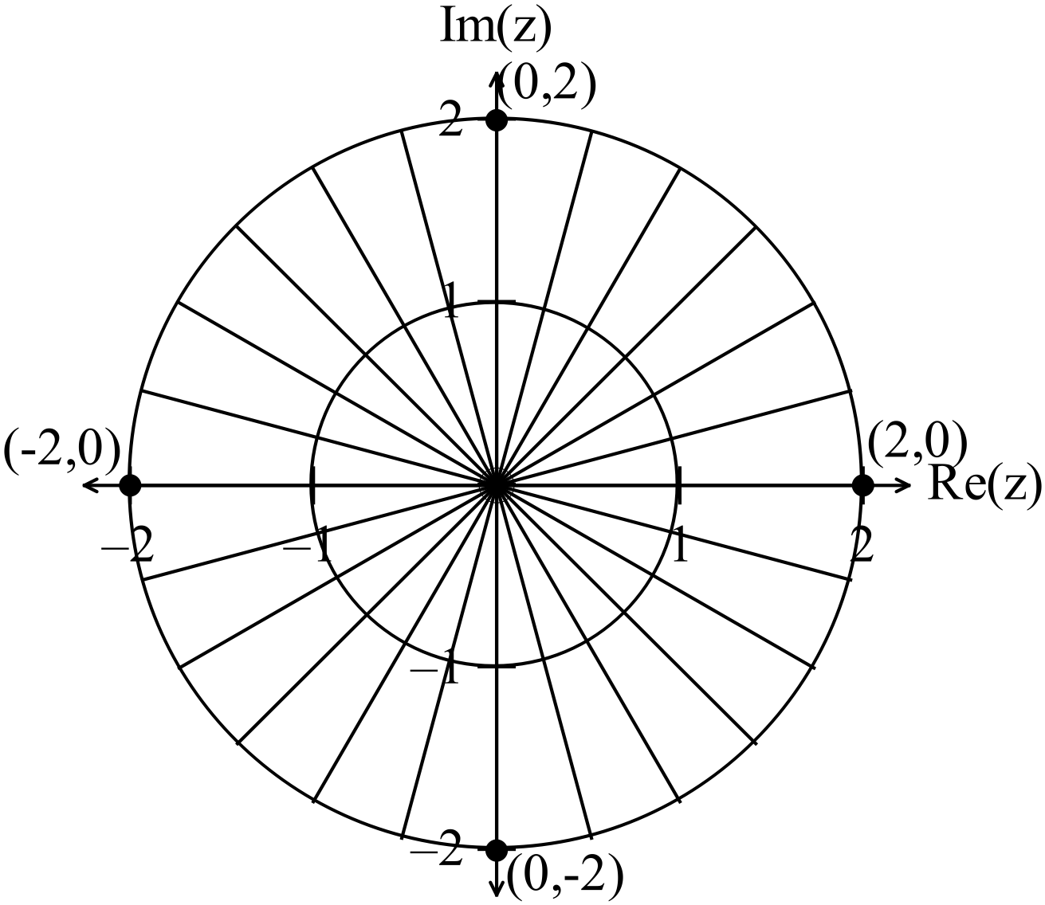
✓✓ (2)

(iii) is equivalent to 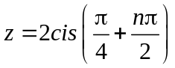
whereas 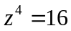 is equivalent to 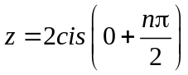which means the
starting positions of the roots are 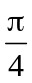apart. ✓ (1)

4. (13 marks)
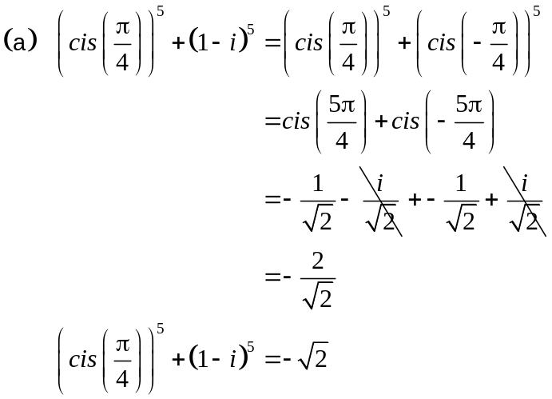
✓
✓
✓
(3)
(b)

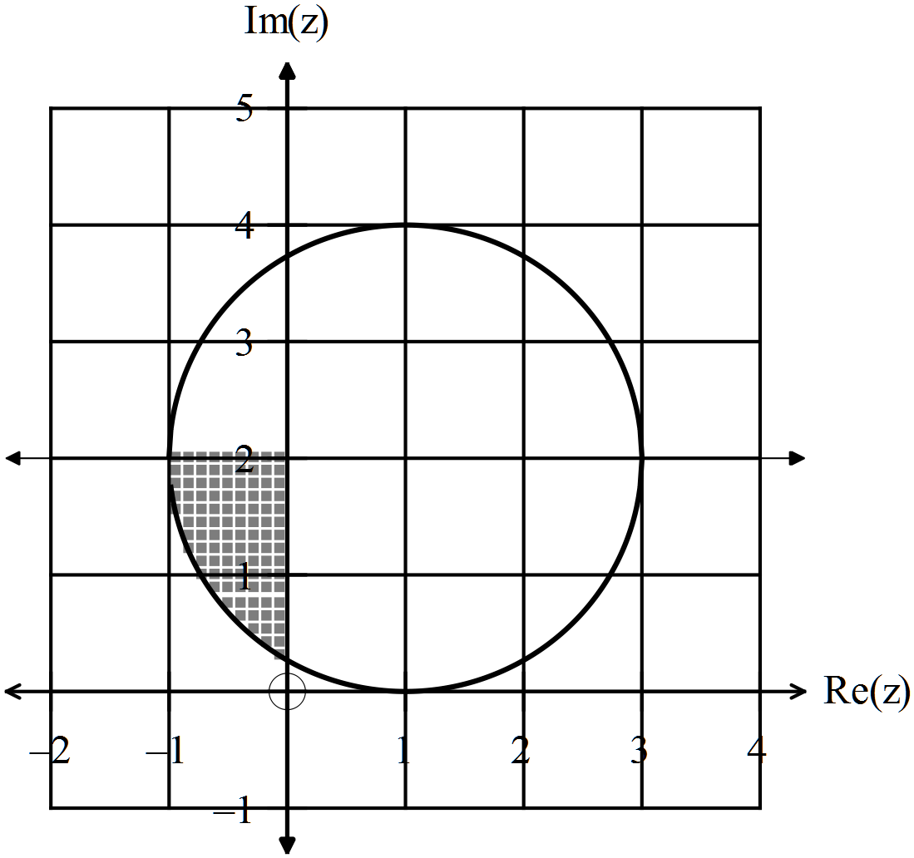
✓
✓
✓

(c) 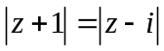 ✓✓ (2)
(d) 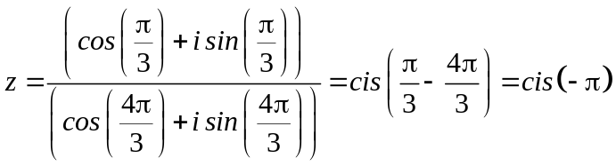 ✓
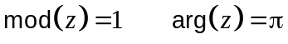 ✓

(e) 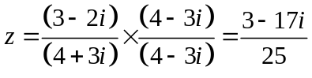 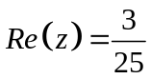 (2)
✓ ✓ ✓
5. (8 marks)
(a) 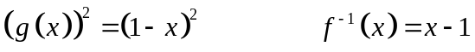
✓
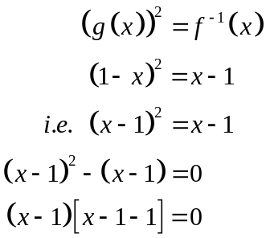
✓
✓
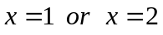

(b) (i) 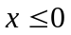 ✓✓ Answers will vary (2)

(ii)  ✓
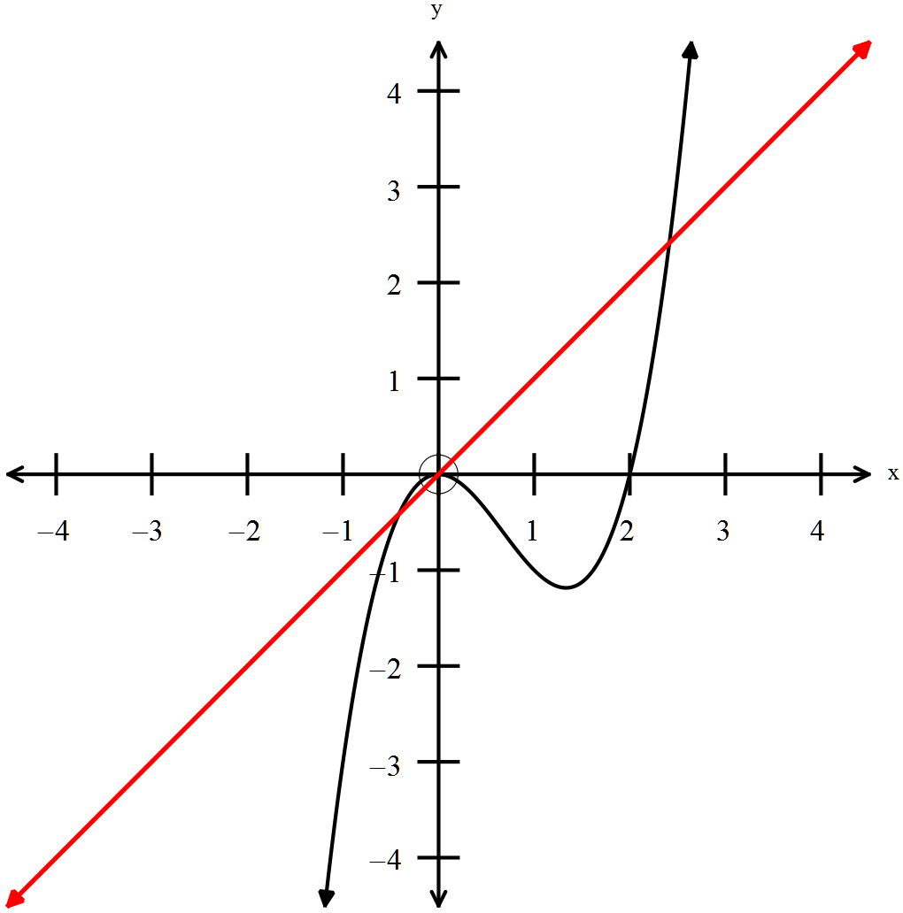
✓
(2)

(iii) 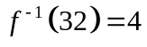 ✓ (1)

END OF SECTION ONE
Section Two
6. (6 marks)
(a) 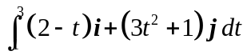
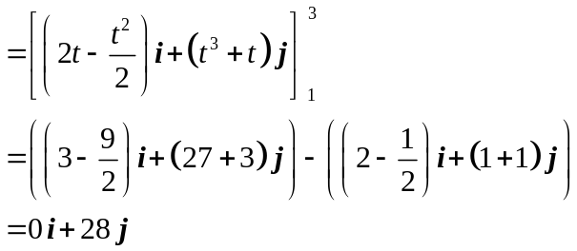
✓

✓

✓

(3)
(b) 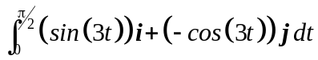
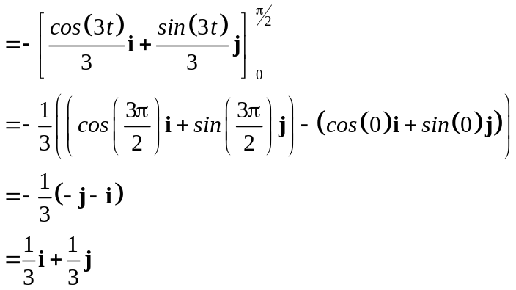
✓

✓

✓

(3)
7. (26 marks)
(a) (i) 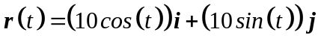
✓

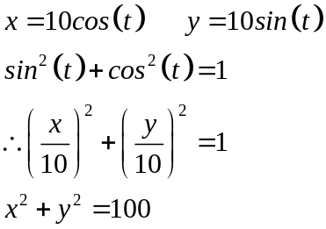
✓

✓

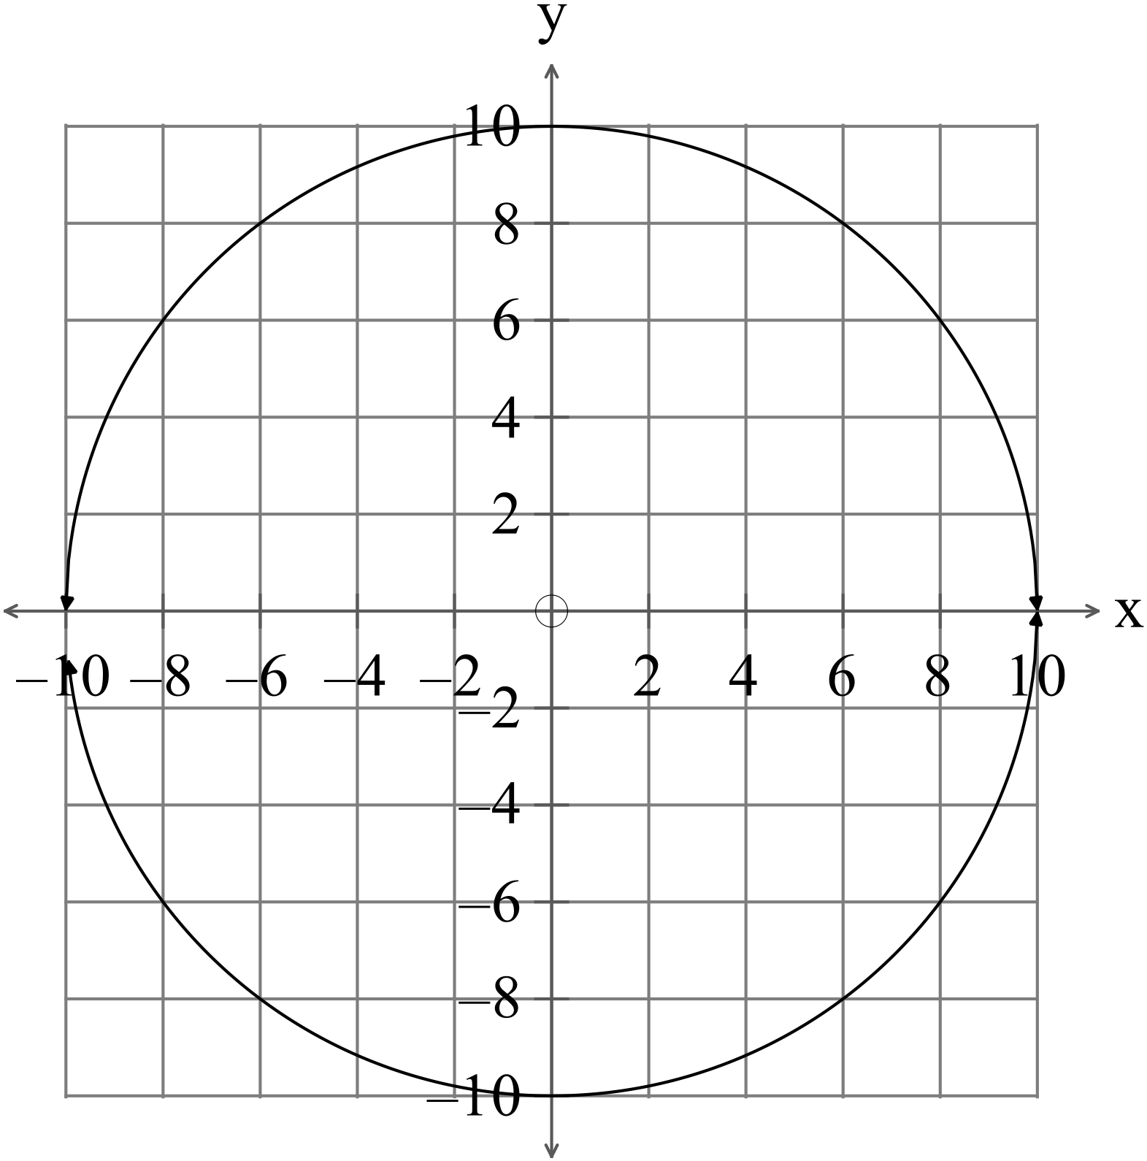
(3)
(ii)
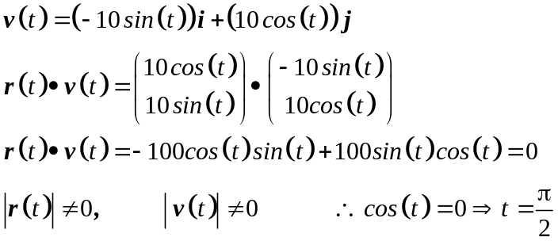
✓

✓

✓

Therefore the position vector is at right angles to the velocity vector.
(3)
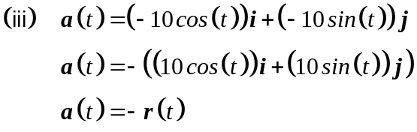
✓

✓

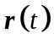 is a position vector, i.e. it goes out from the origin.
Therefore 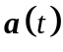 is directed towards the origin. (3)
✓

(iv) 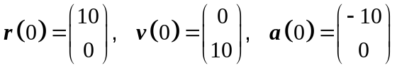
✓

✓

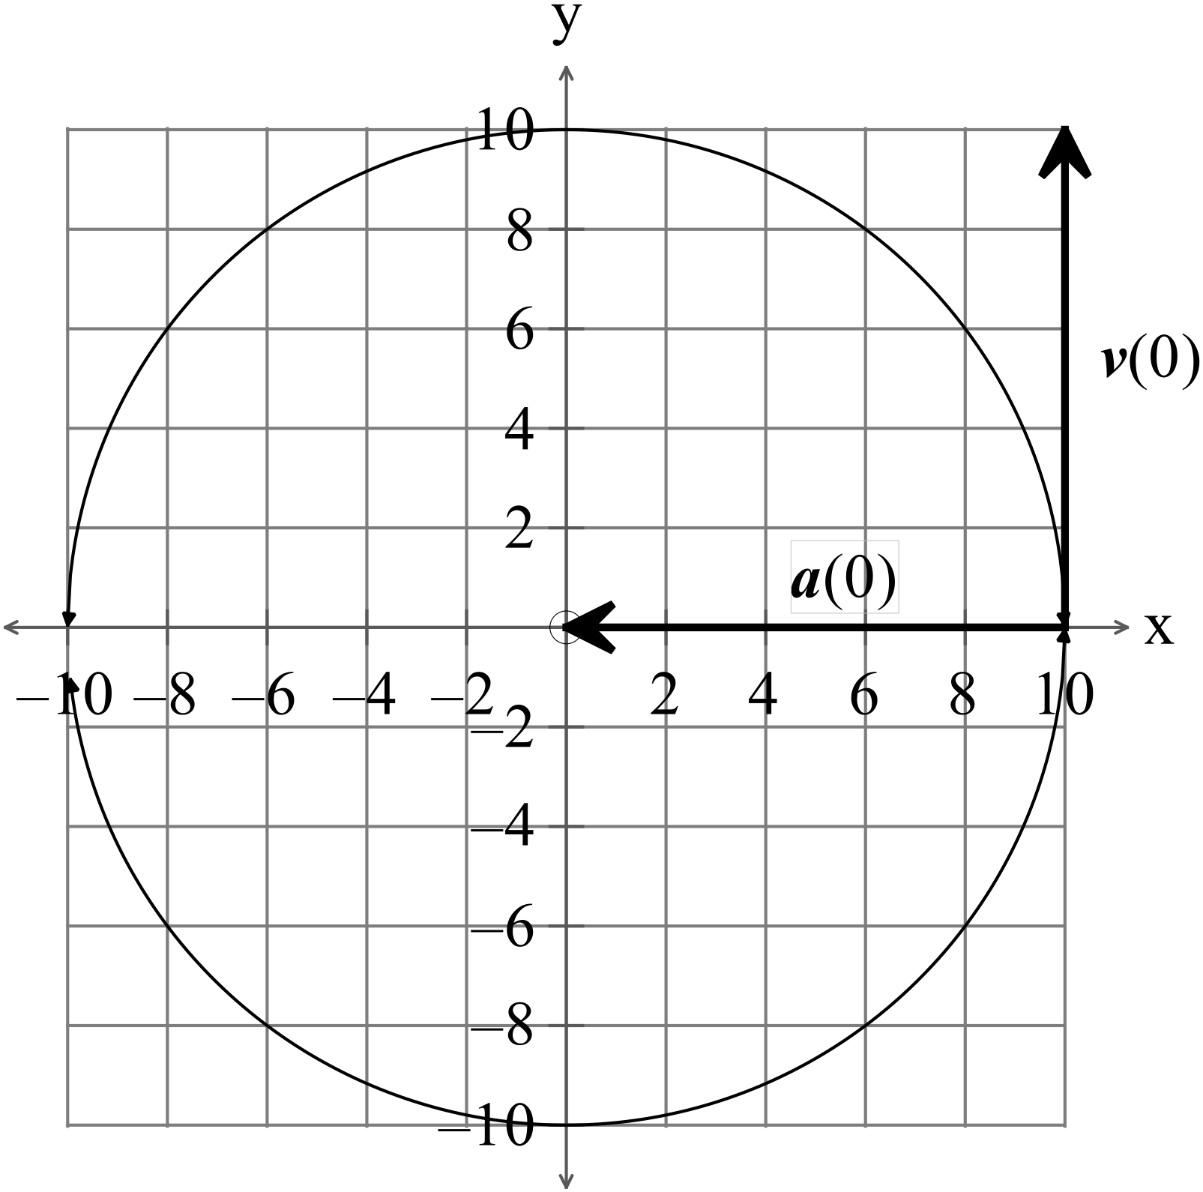
✓

✓

(4)
(v) Speed = 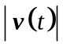
✓

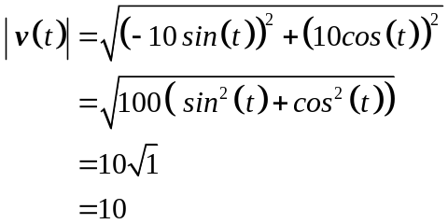
✓

✓

(3)
(b) (i) 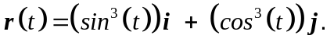
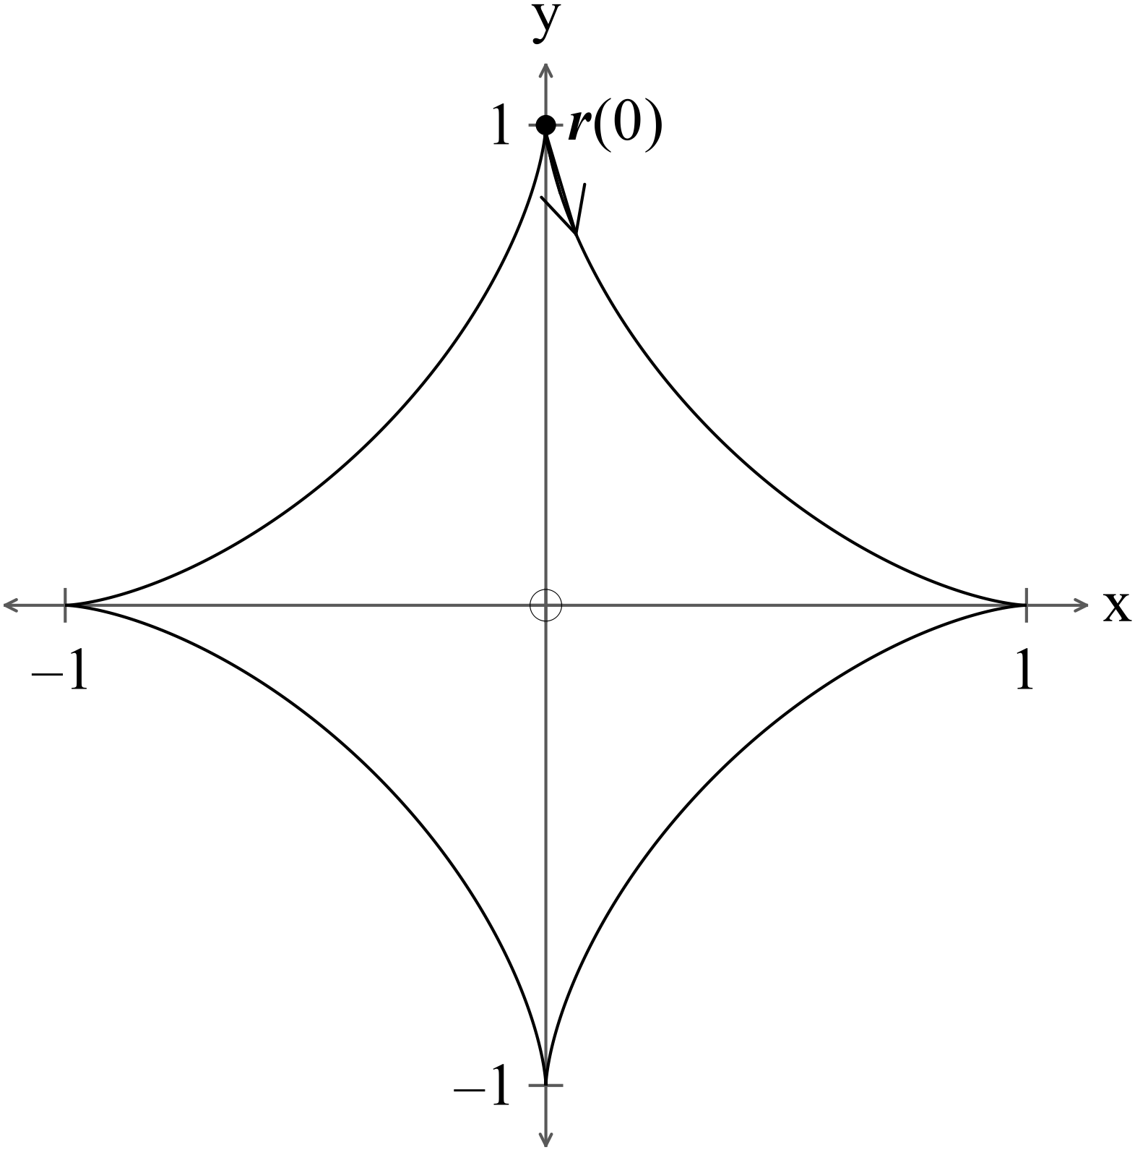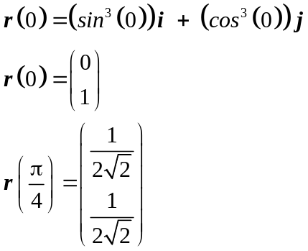
✓

✓

✓ logic

(3)

(ii) (2)
✓

✓

(iii) 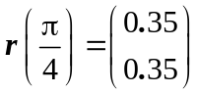
✓

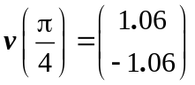
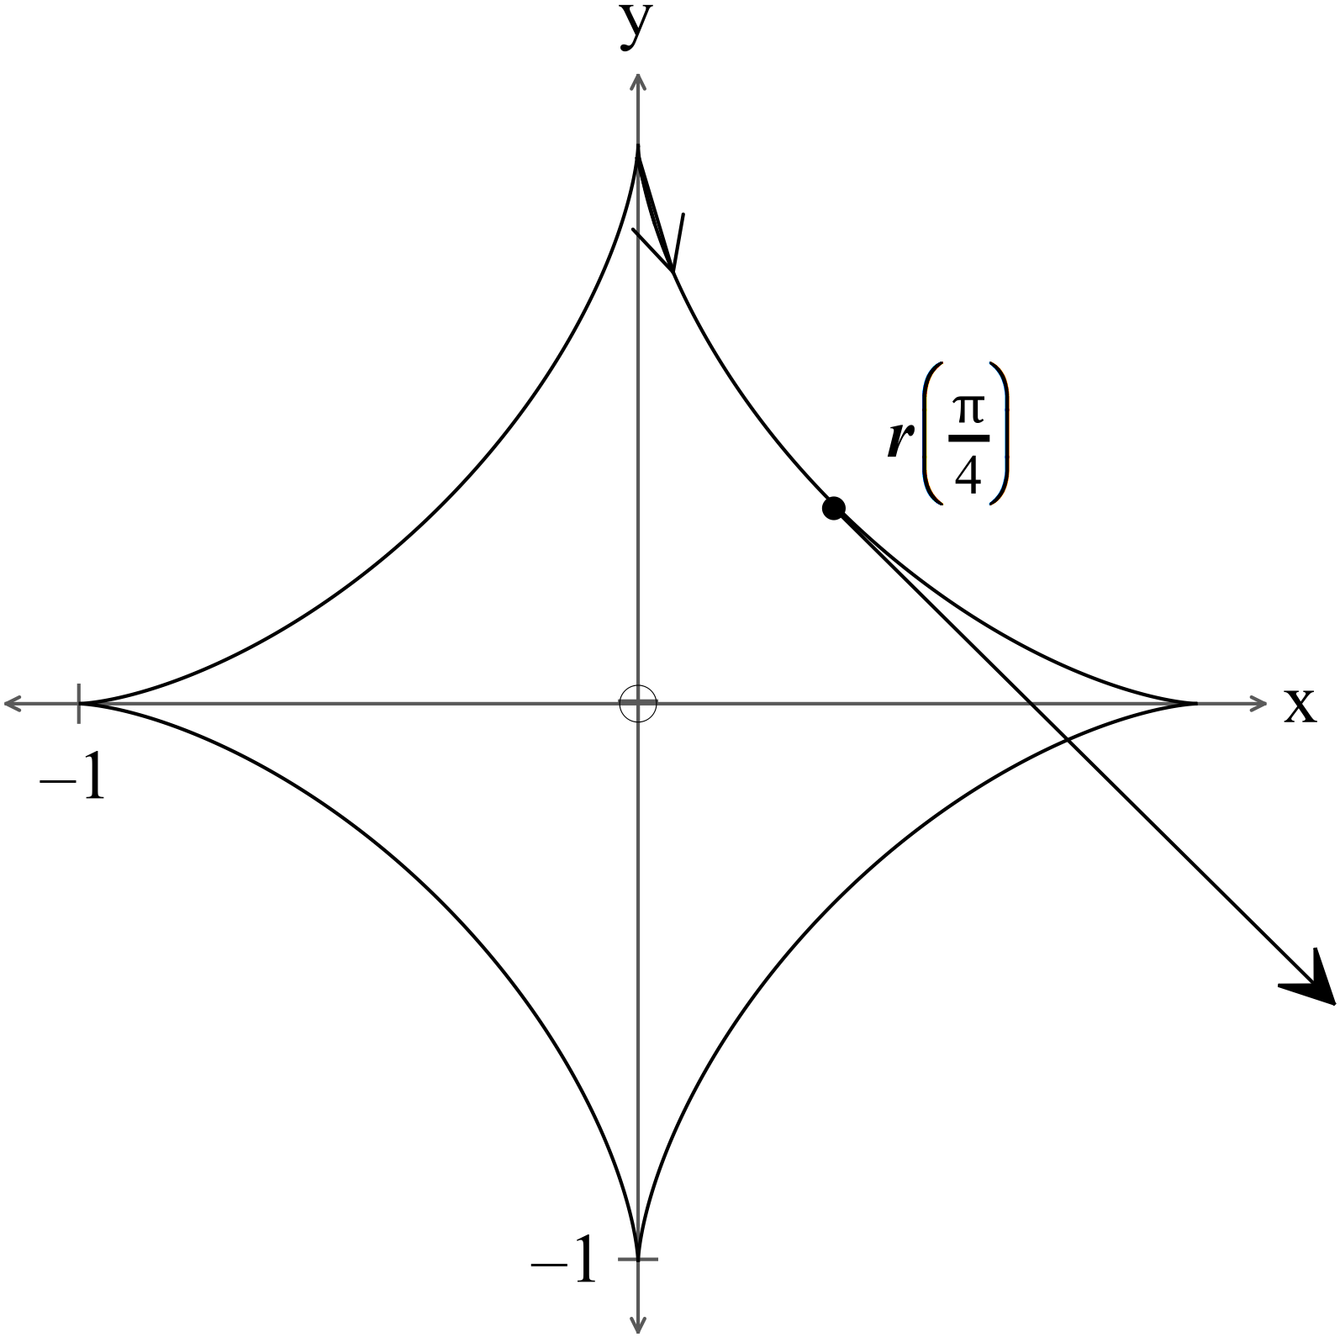

✓

(2)
(iv) 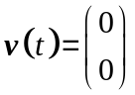 t = ?
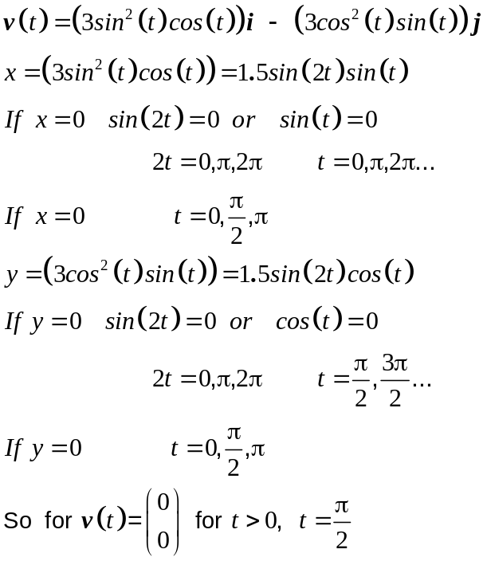 (3)
✓

✓

✓

✓

8. (3 marks)
✓

(a) 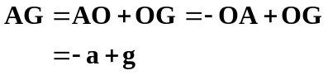 (2)
✓

(b) 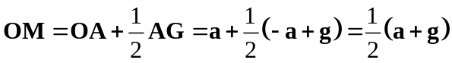 (1)
✓

9. (13 marks)
(a) (i)
✓

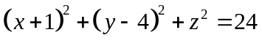 (3)
✓

(ii) 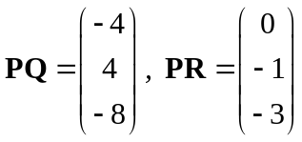
✓

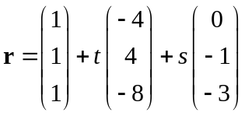
✓✓

Other solutions are possible (3)

(iii)
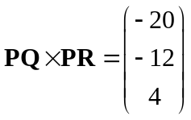 (1)
✓

(b) (i) 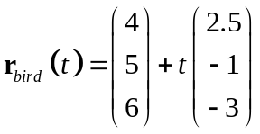
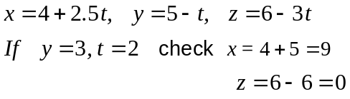
✓

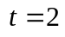 ✓ (1)
(ii) 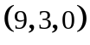 to 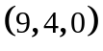 Takes 1 second. ✓ (1)
(iii) 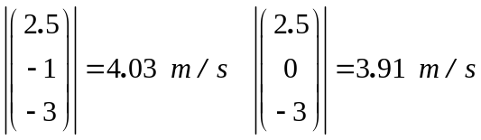 ✓
Change in speed is 0.12 m/s ✓ (2)

(iv) At the bird is at 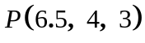
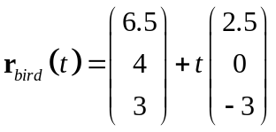
After one second (when the mouse gets to its hole)
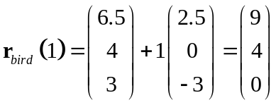 the bird arrives at the nest,
so they both arrive at the hole together.
Let’s hope the mouse does not have a long tail!!!

10. (12 marks)
(a)
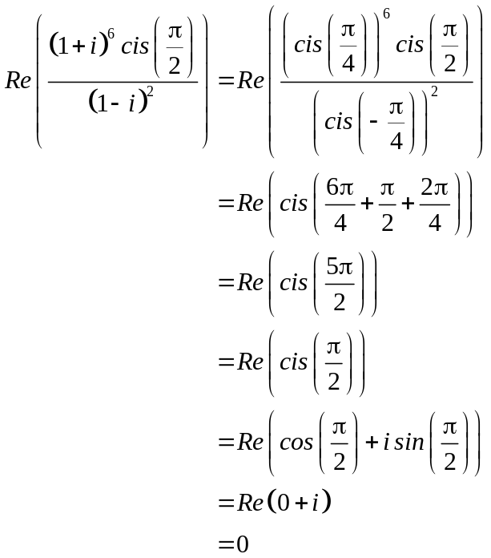
✓

✓

✓

(3)
(b)
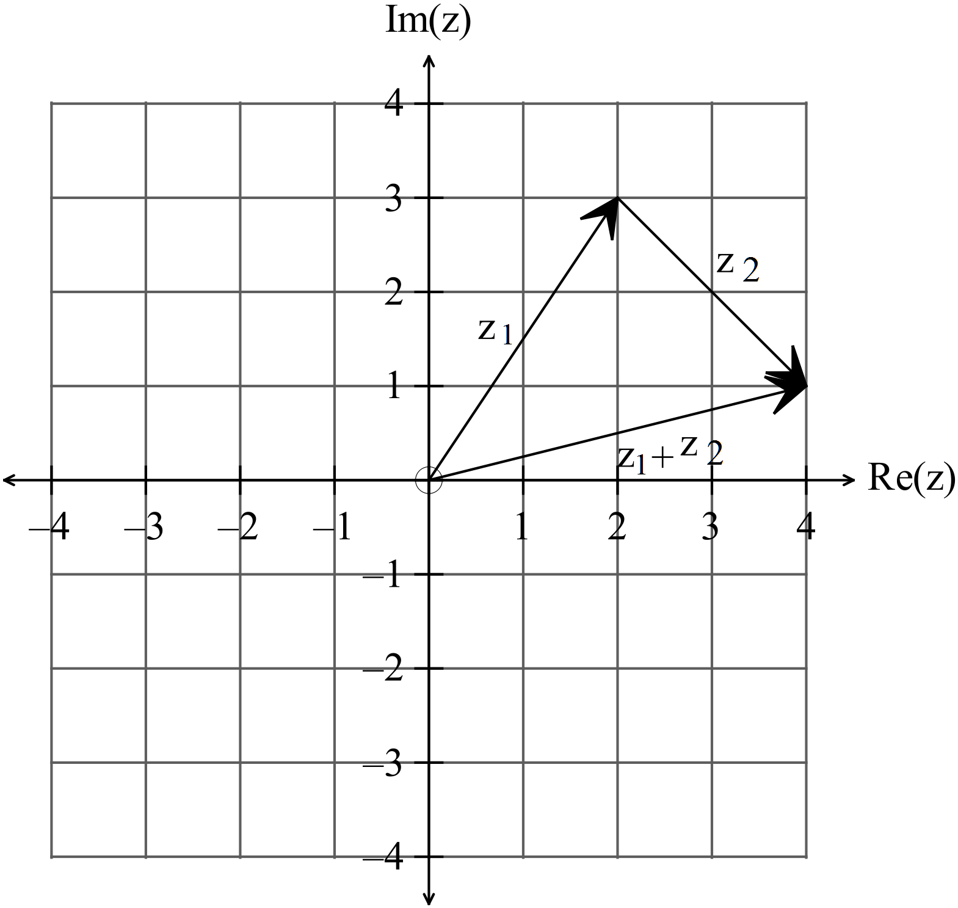
✓

✓

(2)

(c) (i) 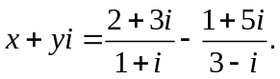
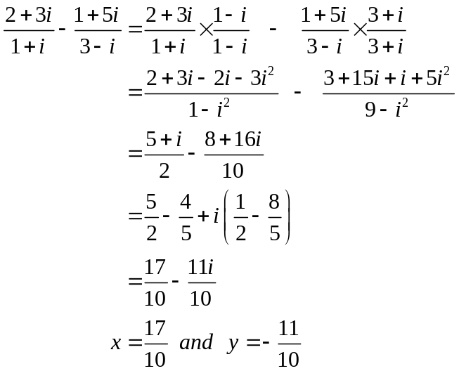
✓ ✓

✓ ✓

✓✓

(6)
(ii) 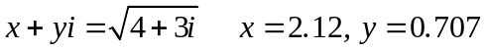 ✓ (1)

11. (6 marks)
(a) 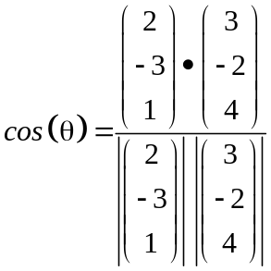 ✓

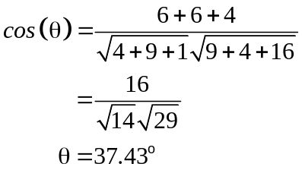
✓

(2)

(b) The projection of 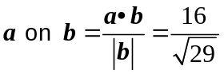 (2)
✓ ✓
(c) 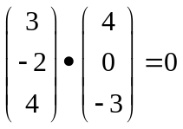 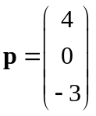 ✓✓ Answers will vary (2)

12. (17 marks)
(a)
✓

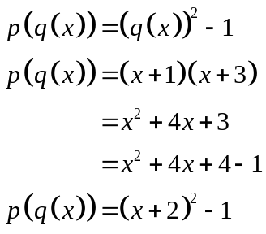
✓

✓

✓

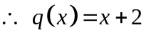
(4)

(b) (i) 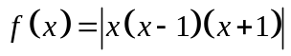 ✓ (1)
(ii) 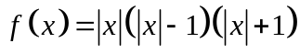 ✓✓ (2)
(iii) 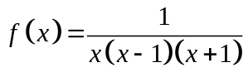 ✓✓✓ (3)

(c) (i) 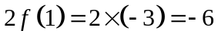 ✓ (1)
(ii) 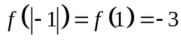 ✓ (1) (iii) 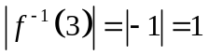 ✓ (1) (iv) True ✓ (1) (v) True ✓ (1)

(d) (i) 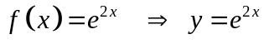
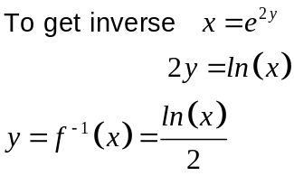
✓ (1)

(ii) 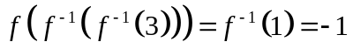 ✓ (1)
13. (4 marks)
(a)
✓ ✓ (2)
(b) (i) 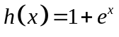
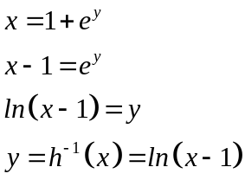
✓ (1)
(ii) 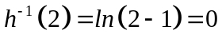
✓ (1)

14. (4 marks)
(a) 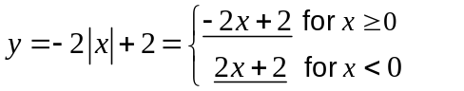 (1)
(b) 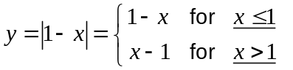 ✓ (1)
(c)
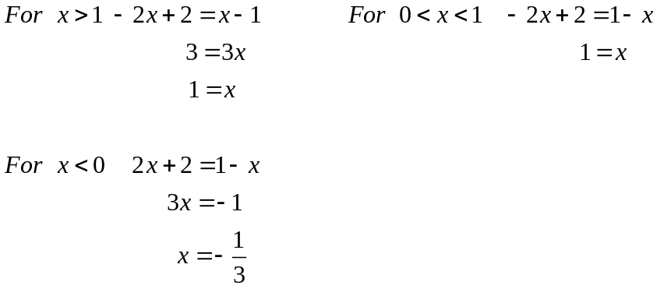
✓

✓

(2)

15. (3 marks)
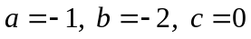
✓ ✓ ✓ (2)

16. (5 marks)
Prove that 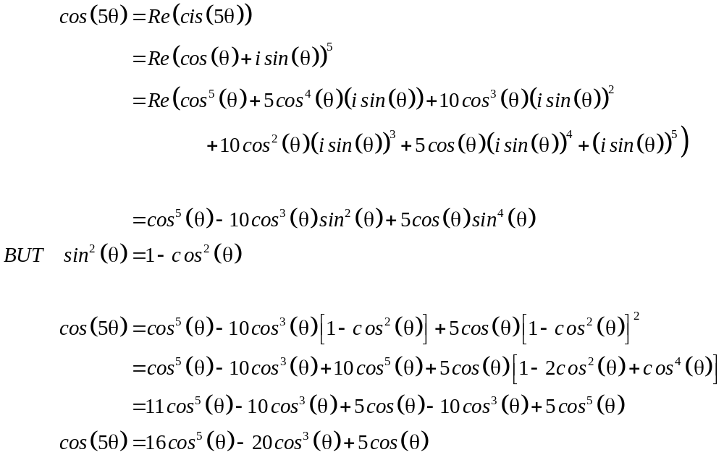
✓

✓

✓

✓

✓

(5)

END OF SECTION TWO

